## PROGRAM DEFINITION

|  |
| --- |
|  |
| Program untuk melakukan action approval |

## RELATED TABLES

|  |  |
| --- | --- |
|  | **Access** |
|  |  |
|  |  |

## ROLES

|  |  |
| --- | --- |
|  | **Test** |
| * Di akses dan di atur oleh admin yang berwenang |  |

## INITIAL PROCESS

|  |  |
| --- | --- |
|  | **Test** |
|  |  |

## Form 1:GFF00900 – Action Approval

**USER INTERFACE:**

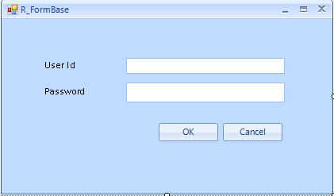

### BUTTON DEFINITION

|  |  |
| --- | --- |
|  | **Test** |
| * OK   + Menjalankan OK Process * Cancel   + Menutup Form dan Membatalkan Process |  |

### OUTPUT

|  |  |
| --- | --- |
|  | **Test** |
|  |  |

### ROLES

|  |  |
| --- | --- |
|  | **Test** |
| * Di isi oleh admin yang berhak melakukan activitas locker |  |

### INITIAL PROCESS

|  |  |
| --- | --- |
|  | **Test** |
| * Siapkan Parameter untuk di tampung   + @COMPANY_NO   + @ACTION_CODE   + @DATE   + @REQUEST_BY   + @DETAIL_ACTION   + @USER_ID |  |

### DISPLAY PROCESS

|  |  |
| --- | --- |
|  | **Test** |
| * Siapkan Form popup dengan Judul Action Approval   + User Id     - Value simpan ke @USER   + Password     - Value simpan ke @PASSWORD * Siapkan button OK Cancel |  |

### OK PROCESS

|  |  |
| --- | --- |
|  | **Test** |
| * Jalankan RSP_GS_VALIDATE_USER_ACT_APPR dengan parameter:   + CCOMPANY_ID = Login Company Id   + CUSER_ID = Input User Id   + CPASSWORD = Encrypted Password   + CACTION_CODE = Action Code dari program pemanggil (exp: GSM01501)   + CUSER_LOGIN_ID = User Login Id |  |
| * Jika terdapat error, tampilkan error dan batalkan process. |  |

### Cancel PROCESS

|  |  |
| --- | --- |
|  | **Test** |
| * Batalkan process dan tutup Form |  |

# CR LIST

|  |  |  |
| --- | --- | --- |
| **CR** | **Description** | **Notes** |
|  |  |  |
|  |  |  |